**Guideline to Access Nuvepro account and Usage**

**To understand the account creation and how to use it, please follow the below mentioned steps:**

1. Use the URL provided in the email to login onto the Nuvepro-Greatlearning interface.

URL: <https://greatlearning.nuvepro.io>

1. Follow the link as given on the Olympus portal which should take you to a screen similar to the one given below:

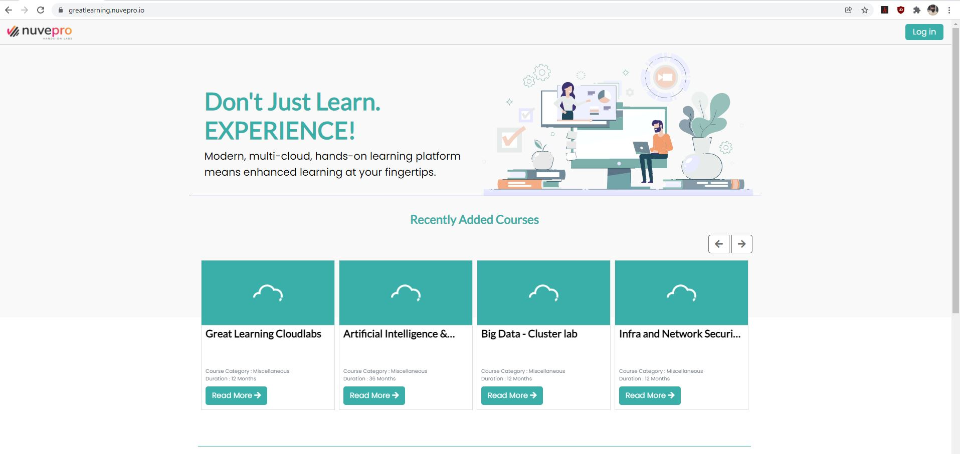

1. Click on the login button available at the top right corner. This should take you to a page similar to below:

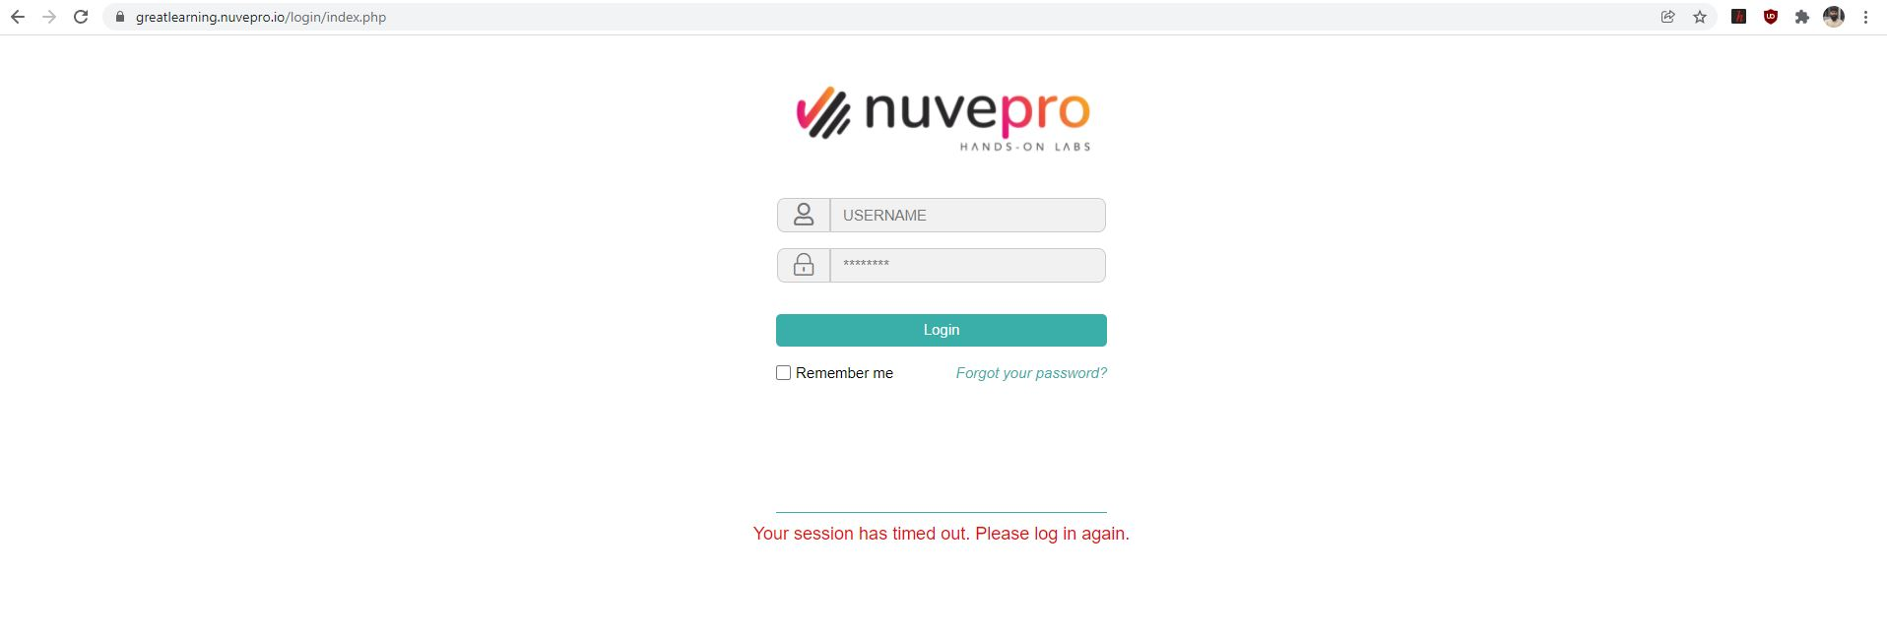

1. Enter the credentials that you have received in order to access the portal. Once the correct username and password is entered. It will take you to the next page that will look as following:

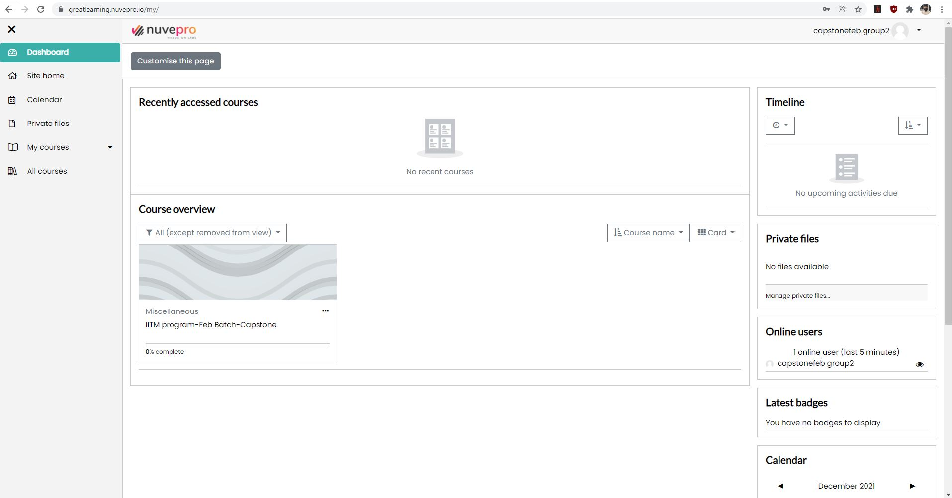

1. Click on the IITM program-feb batch-capstone. Please ignore the month part. For every batch this will keep on updating. Click on the course link that will take you to a page that will look as following:

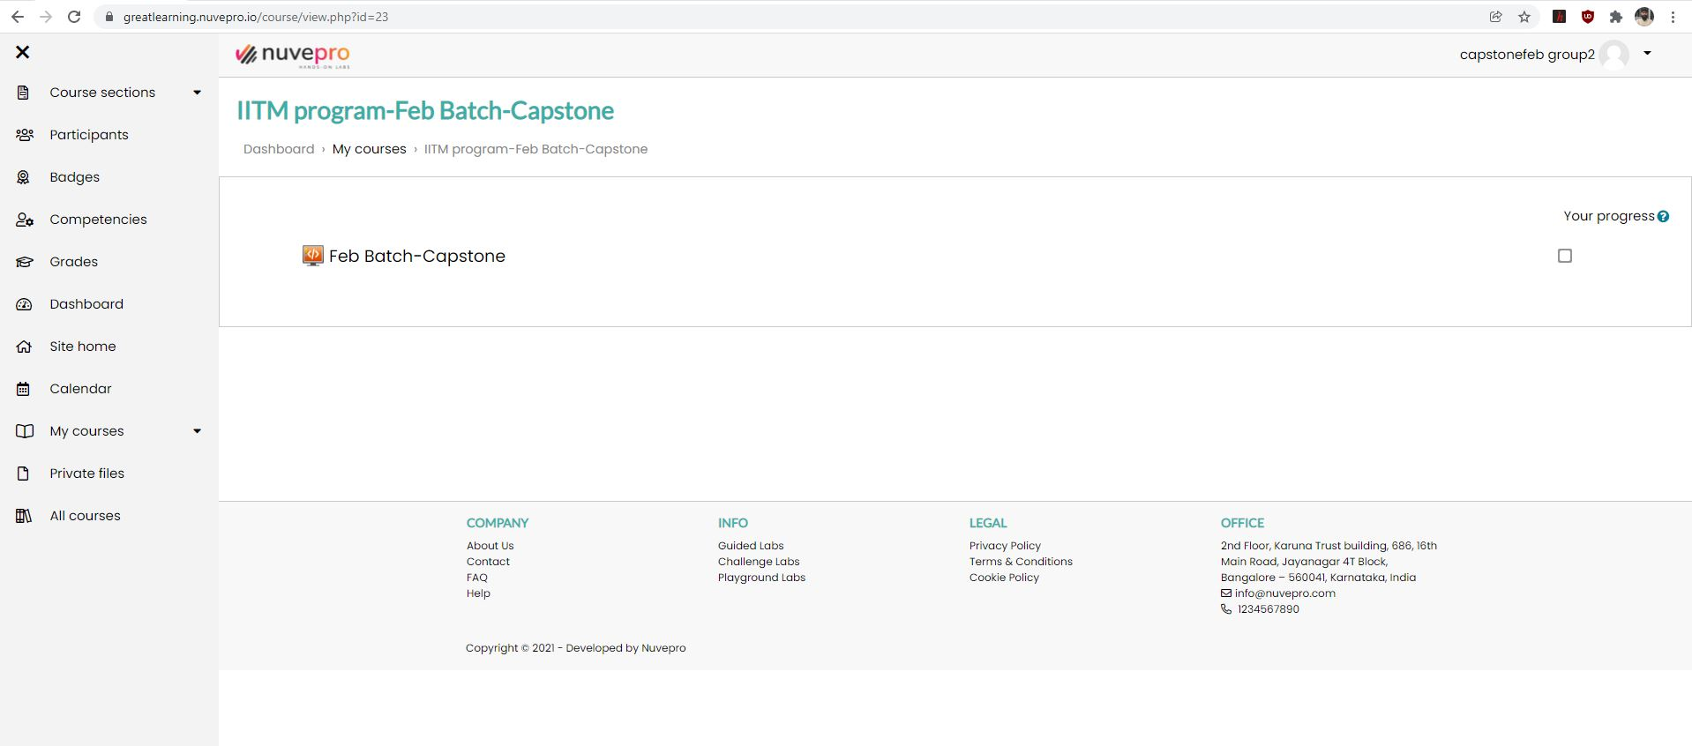

1. Click on the capstone lab button as mentioned in the above picture. After clicking, it will take you to the next page, that will look as following:

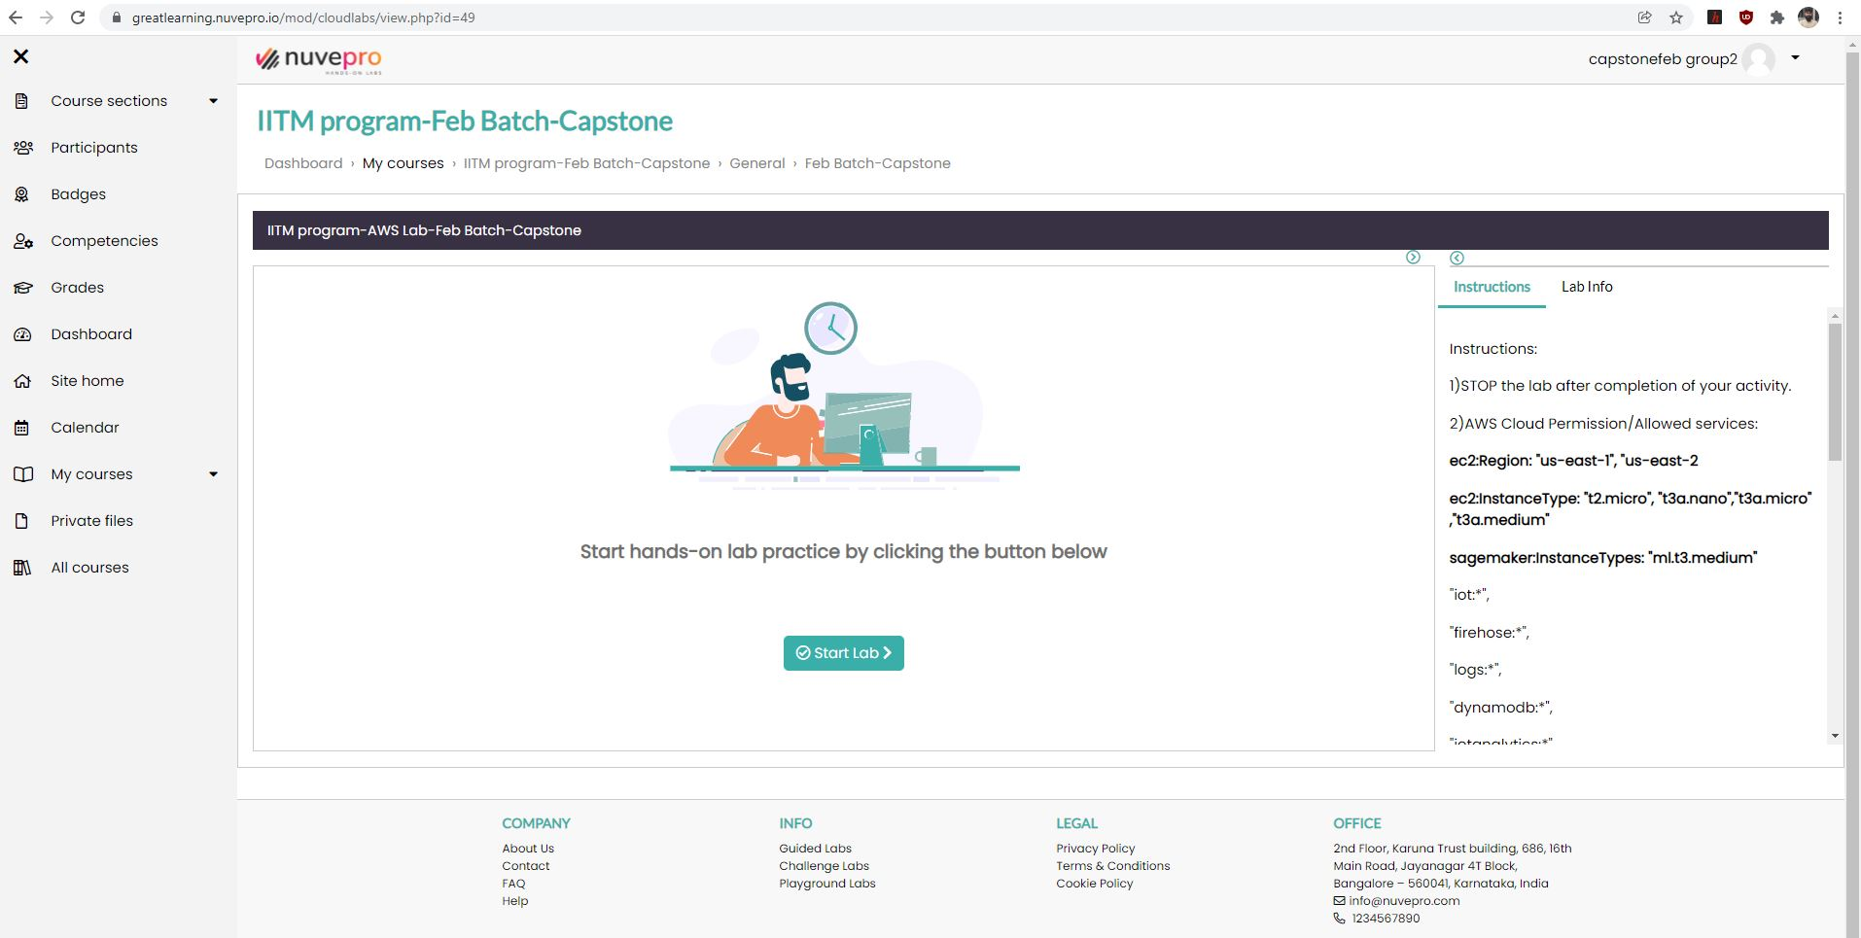

1. Click on “Start Lab” on the above mentioned screen. Also, please go through the Instructions section of the left side of the screen to learn more about involved services.
2. It will take a few minutes to start the lab after clicking on the button. Once the lab is started it will look similar to following:

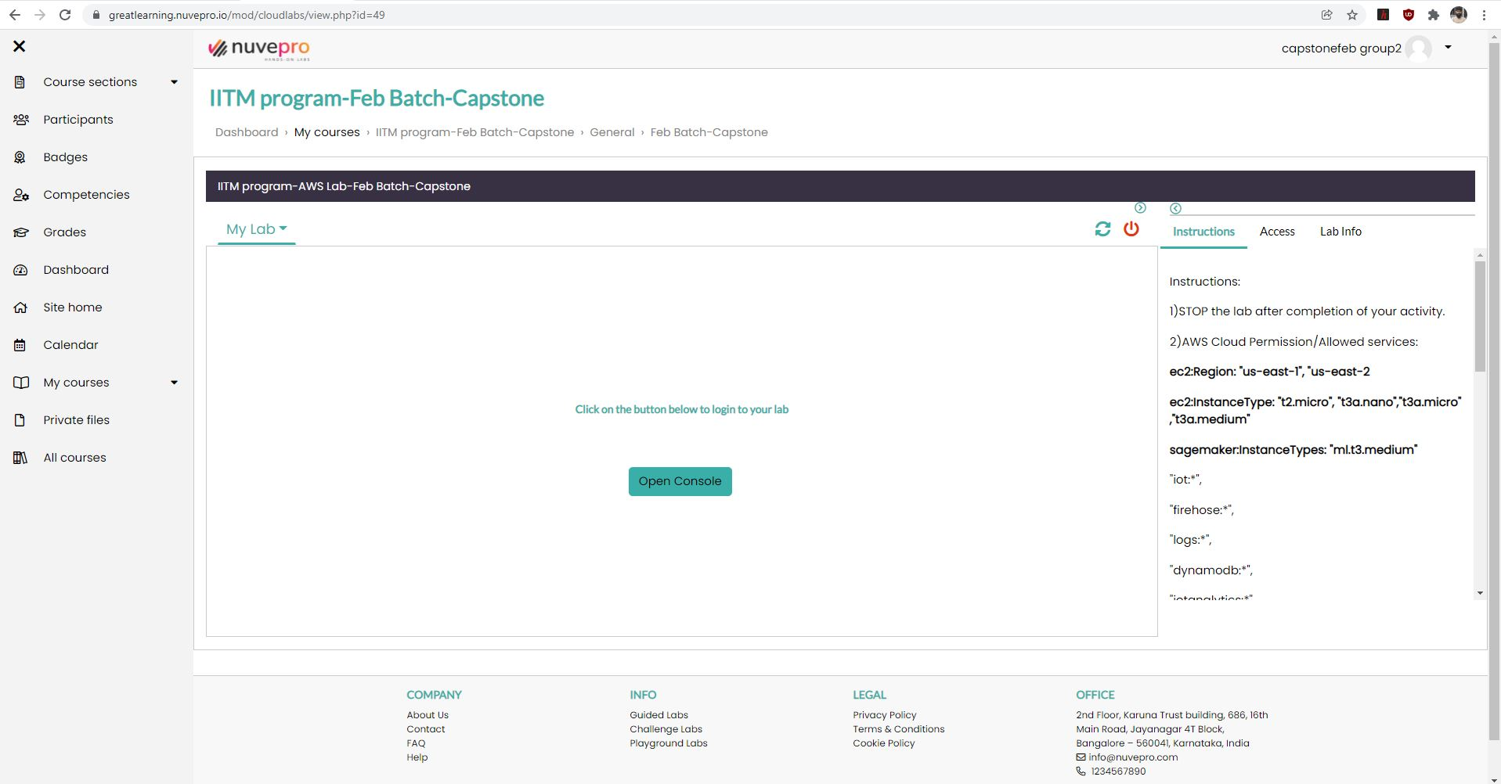

1. Once you click on the Open Console button, it will open a new tab which will allow you to access the AWS console. **To access the console you need to click on Access button and it will appear similar to below:**

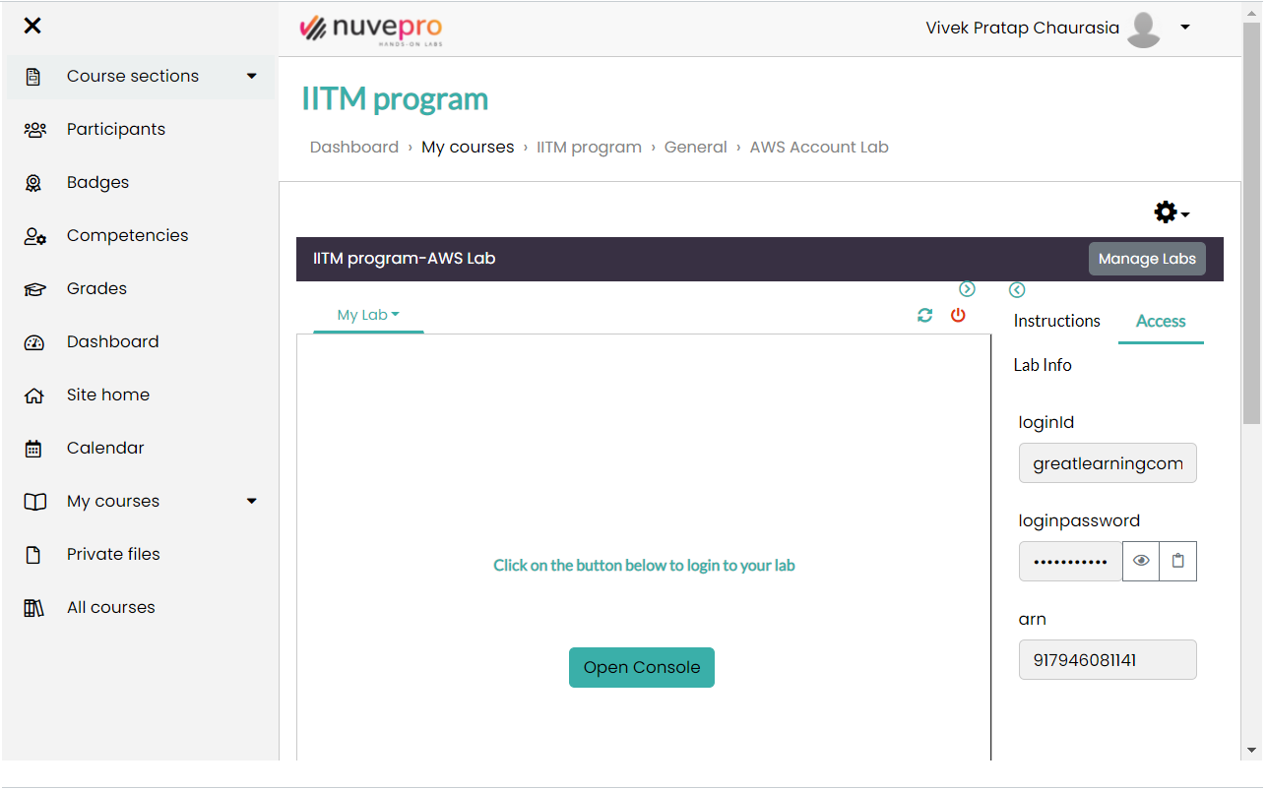

1. Clicking on the Open console will open the new webpage similar to below, where you are supposed to enter credentials shown on the above page.

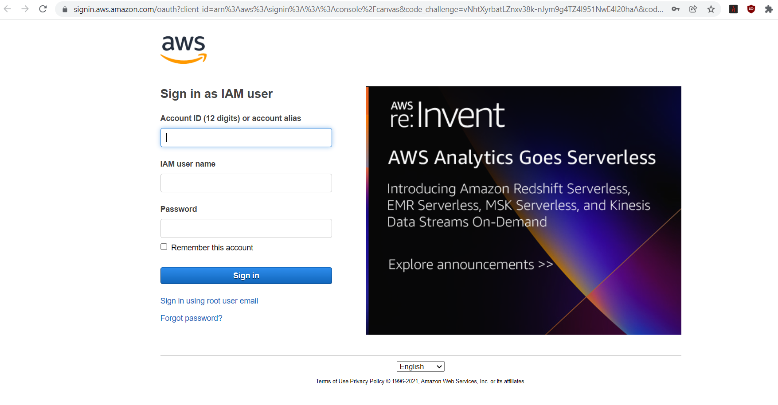

Under Account ID enter the arn mentioned on the previous page, copy the username from previous page and copy it under IAM user name and copy the password and paste it at the designated place. Once the correct credentials are added you should be able to see a page similar to below.

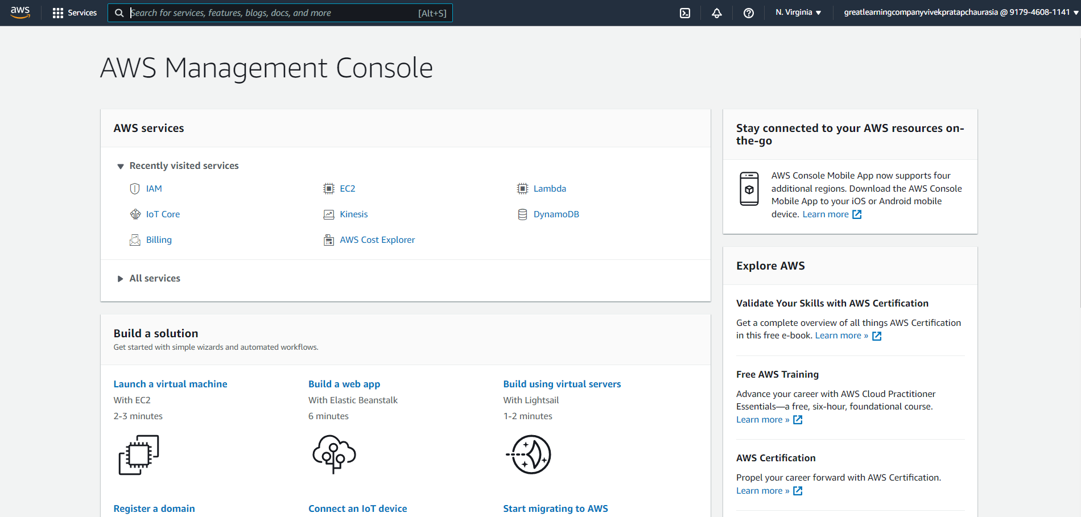

1. Now you should be able to access all the services that are mentioned in the FAQ file and instruction section of nuvepro console page on Olympus.
2. Once you have logged in, you should first secure the credentials to access and perform the SDK operations using python on different AWS services. This will help in performing programmatic operation on services for kinesis, dynamodb and other relevant services.
3. You will get the access for these services by accessing the IAM console. Enter IAM on the search bar and click on the suggested result. This should take you to the following page:

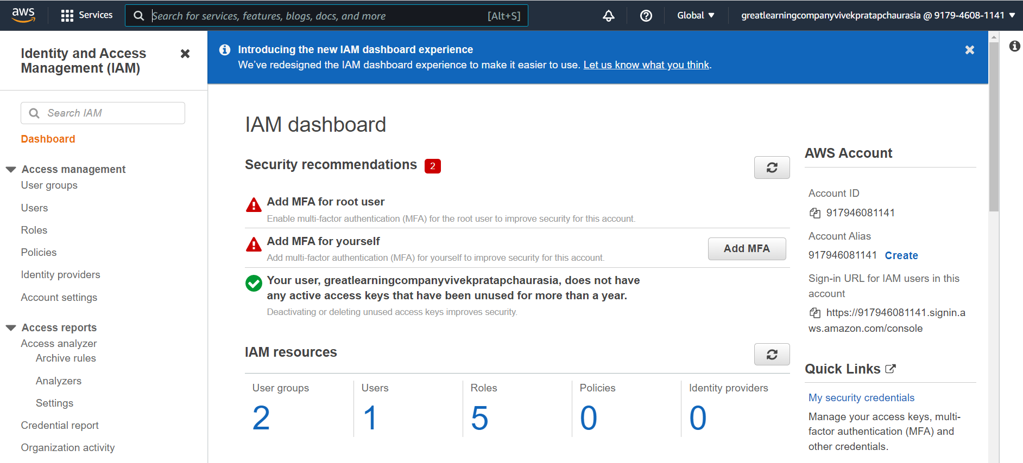

1. On the right pane; you will see *My security credentials,* click on the link which will open the following page.

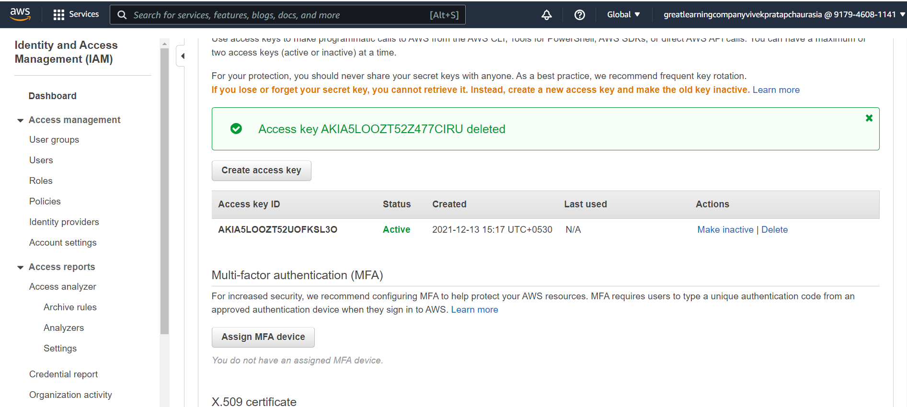

1. Click on Create access key and it will create a new access key similar to the following image and download the csv file. This will ensure that you have access key and secret key to perform SDK operation.

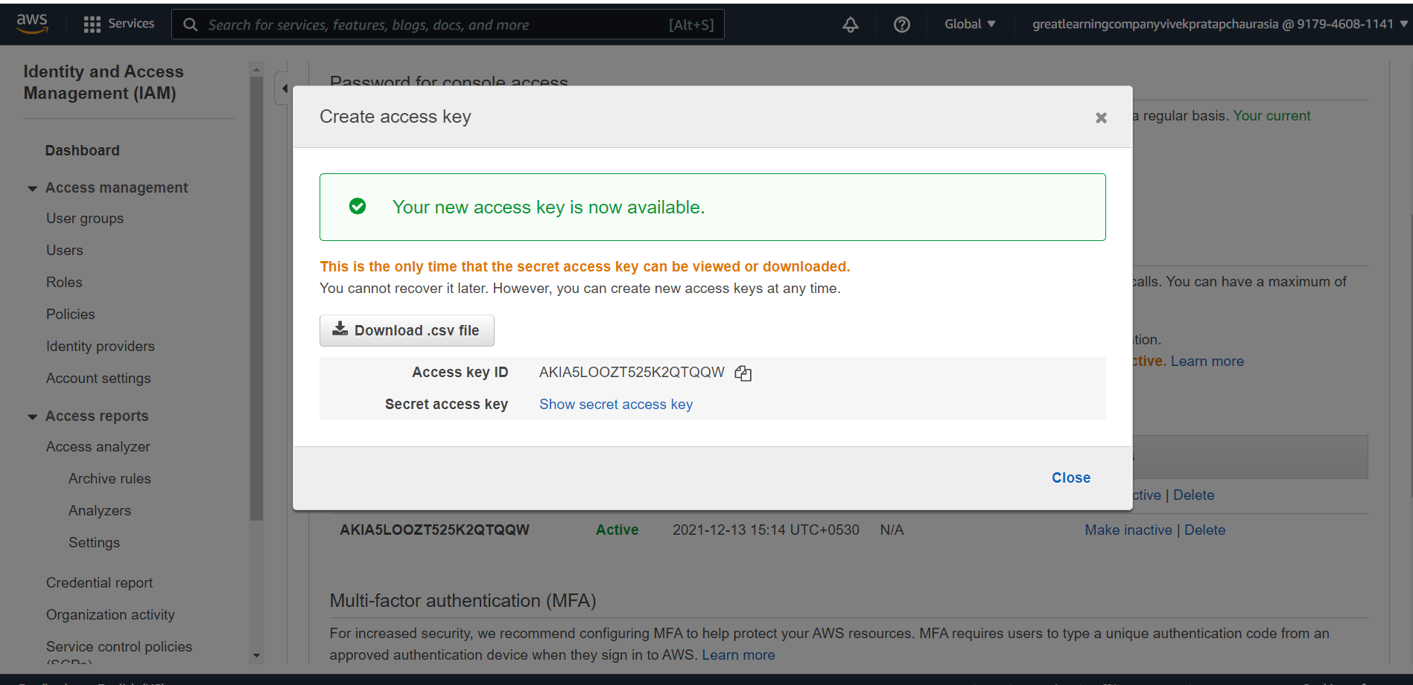

**Follow the instructions below to configure the CLI access for your**

1. Install the AWS CLI for your operating system using the link given below <https://docs.aws.amazon.com/cli/latest/userguide/install-cliv2.html>
2. Run the command *aws configure* in your computer’s terminal and enter the fields as shown in the image below

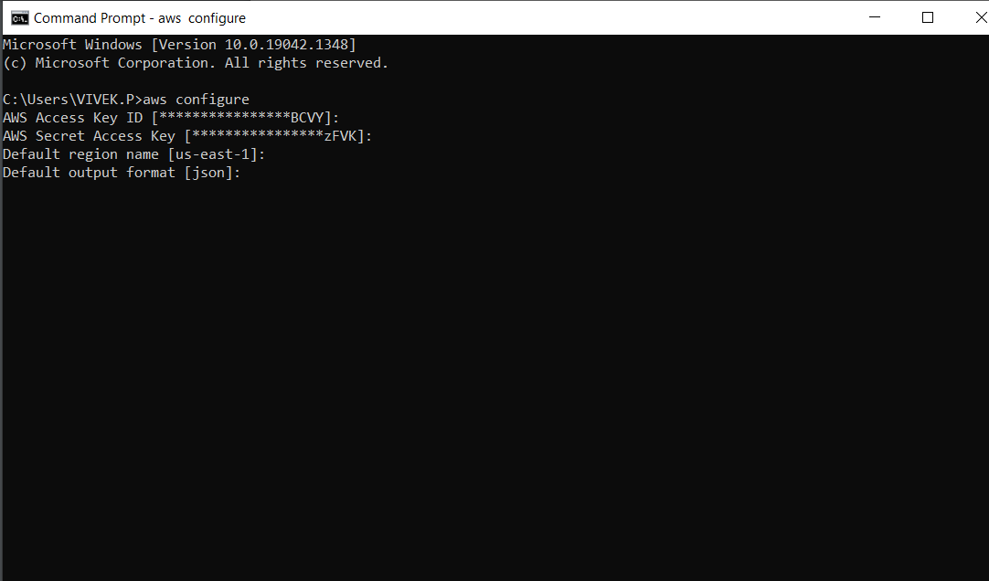

1. We have already retrieved the CLI credentials for the AWS account as shown in the images above.
2. Enter the retrieved credentials on the above console. Please find the details for different OS’ below:
   1. Linux : .aws/credentials
   2. macOS: /Users//.aws/credentials
   3. Windows : C:\Users\\.aws.credentials .
3. Please note that the credentials file will have to be created if it does not exist within the .aws folder. To create it run *aws configure* on your terminal.